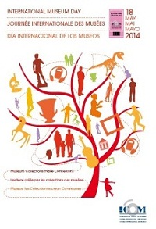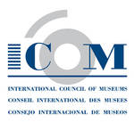

Dear museum professionals, please email us information about activities and visits you are planning to organize in your museum during International Museum Day: [imd@icom.museum](mailto:imd@icom.museum).

Institution name:

City:

Country:

Types of activities to be organised for IMD 2014 (exhibition, conference…):

Description of activities (maximum 800 characters):

Free activities: yes / no; if no, please indicate rates

Phone number:

Fax:

Email:

Full address of the institution:

Website of the institution:

Contact name (please specify whether you wish this information to appear on the International Museum Day 2014 website):

Contact email address (please specify whether you wish this information to appear on the International Museum Day 2014 website):

Please provide also an image in jpeg format (1.5 MB maximum).

We recommend that you send us the information in English, French and Spanish, in order to ensure better visibility on our website.

